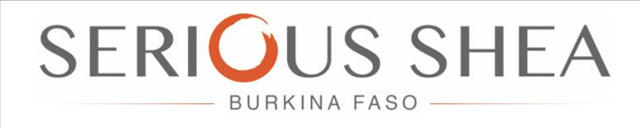

Serious Shea SARL
Ouagadougou
Secteur 29, 01 BP 6433
Ouagadougou 01 – Lot: 24
Section: XT Parcelle: 03
Burkina Faso

11th April 2019
Contact Owner:

Company Name:

Contact:

Position in Company:

Date & Location of Initial Contact:

Business Purpose:

Individual Clients Requirements & Requests per Order:

Follow Up Procedure per Order: Date:

